**Fingerprint Recapture and Replace flow diagram.**

So at the point of recapture the biometric service will perform a check finger-to-finger match, if the match is **equal or greater than six** it then becomes a match and so it generates a green alert to the end user, but if it's less than **six matches** or **zero** it will flag red to the end user that it is not a match.  
A red alert box pops with 2 buttons, **Yes** and **No** for no match. When the user clicks **Yes** it will replace the base fingerprint but when **No** is clicked it will not replace the base fingerprint but will store the recaptured unmatched print.

A validation rule was also implemented to prevent the users from doing multiple recaptures but to recapture after 30 days.

**Formed an Algorithm from the above**

**Step 1:** The first and key requirement is that the patient will have the base fingerprint for you to be able to recapture and be able also to replace the base fingerprint.

**Step 2:** Does the Client have a base finger?

**Step 3:** If yes, perform recapture

**else**

Perform base fingerprint capture before recapturing.

**Step 4:** Recapture Fingerprint

**Step 5:** Perform a finger-to-finger matching (**base** Index against **recapture** Index fingers.)

**Step 6:** Loop the process across all fingers

**Step 7:** Is minimum capture up to six fingers matching?

**Step 8:** Is the match equal to or greater than six? If yes, there is a match, provide feedback.

**else**

**Step 9:** If fingerprint matching is less than six matches, display a red flag with two buttons (Yes and No for no fingerprint match). "No match." Click yes to replace the base fingerprint.

**else**

**Step 10:** Click No to skip the base fingerprint replacement and store the unmatched recaptured fingerprint.

**Step 11:** Apply the validation rule to prevent multiple recaptures. Is recapture less than 30 days?

**else**

**Step 12:** Perform recapture if the previous recapture date equals or exceeds 30 days.

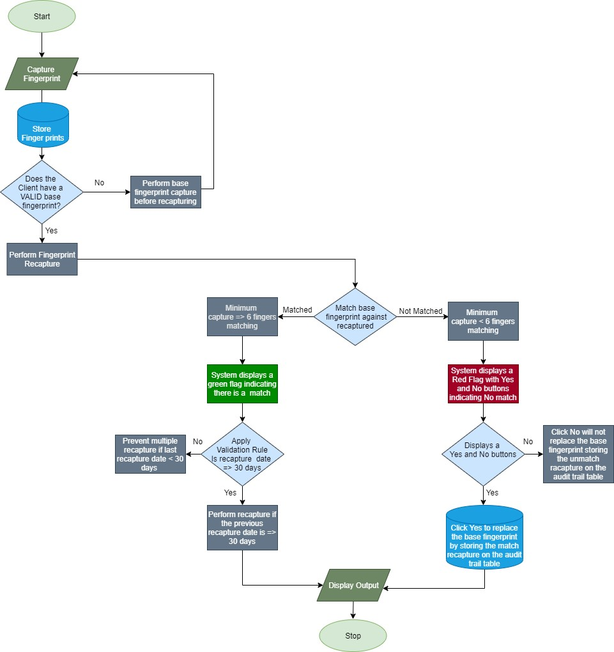

Figure 1: Shows Biometrics Recapturing Flow Diagram